
ONE LIFE
ONE YOU
Nebraska Youth Suicide Prevention Social Media Campaign

ONE LIFE ONE YOU

About the campaign
The One life one you campaign is a social media campaign that was developed by youth for youth with the goal of creating messaging specific for youth to address mental health and suicide.

Overall Strategy
The main objectives of this social media campaign are to:
- Raise awareness about the warning signs of suicide and encourage young people to seek help if they or someone they know is experiencing suicidal thoughts or behaviors.
- Promote the availability of mental health resources and encourage open communication about mental health.
- Reduce the stigma around help seeking for mental health issues and ultimately prevent youth suicide.

Target audience
Suicide is the second leading cause of death for youth aged 10-25. This youth-led campaign aims to provide messaging that targets this age group and helps raise awareness, promote resources, and reduce stigma.

We need your help!
Help us spread the word and reduce stigma by using this social media campaign toolkit to post on your social media accounts!

Communication goals

The goals of the messaging in this campaign are to:
- Increase awareness of the warning signs of suicide among young people.
- Encourage young people to seek help if they or someone they know is experiencing suicidal thoughts or behaviors.
- Promote the availability of mental health resources and support for young people.

Key Messages

The key messages of the campaign are organized into three main content areas:
- Awareness and Education
  - Awareness and education messages include warning signs & steps for action, stigma and myth busting, how to start a conversation about mental health, and community specific awareness.
- Resources/Help
  - Resource and help messages include local and national resources, online resources, and other information about how to seek help.
- Encourage/Inspire
  - Encourage and inspire messages include normalizing and promoting help-seeking behaviors, acknowledging and validating feelings, and messages of hope.

What to post

A library of shareable graphics is available for you to use on Facebook, Instagram, and Twitter.

Link to toolkit: https://youthsuicideprevention.nebraska.edu/resources/one-life-one-you/

Be sure to use our hashtag when posting: #oNElifeoNEyou

Contact

Megan Allen
Senior Research Specialist
University of Nebraska Public Policy Center | ppc.nebraska.edu
megan.allen@nebraska.edu


This campaign is supported by:
The Nebraska Youth Suicide Prevention Grant.

Special thanks to the youth who helped develop this campaign: Ellie Bovaird, Susie Bovaird, Bhagya Pushkaran, Ashlyn Dickmeyer, Reem Ahmed, Meghan Dupre, and Sarah Erdmann.

Campaign Content
*A zip folder with all of the graphics is available for download on our website: https://youthsuicideprevention.nebraska.edu/resources/one-life-one-you/

Awareness and Education
  - Warning signs and steps for action, stigma/myth busting, how to start the conversation, community specific
- Caption | - Media Link | Recommended Posting Date | Photo
- Not sure how to be there for a friend in need? Start by simply listening without judgement and let them know you care. #OneLifeOneYou #YouMatter #SuicidePrevention | https://www.canva.com/design/DAFYO585fZE/-CokpDvCbjFh2lUWdbOdgw/view?utm_content=DAFYO585fZE&utm_campaign=designshare&utm_medium=link&utm_source=editor |  | - 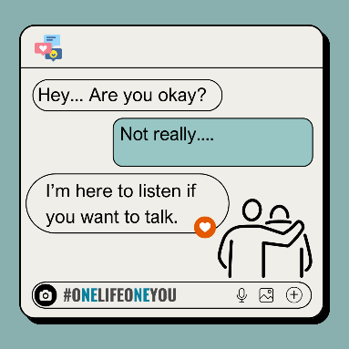
- Numbers can't measure the strength it takes to battle mental health challenges, but they can guide us toward better support. You are not alone. Mental health is not a weakness. #OneLifeOneYou #YouMatter #SuicidePrevention | - https://www.canva.com/design/DAFbU8r6wok/NOKpVulwzWrJ5QggbTbVQw/view?utm_content=DAFbU8r6wok&utm_campaign=designshare&utm_medium=link&utm_source=editor |  | - 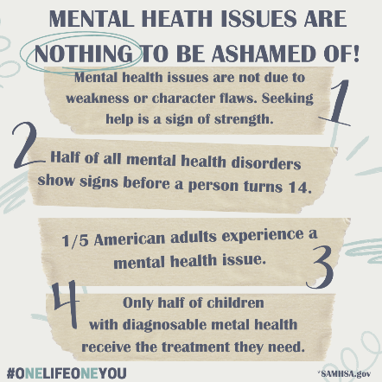
- Let's shatter the myths, break the silence, and embrace the truth about mental health. #OneLifeOneYou #YouMatter #SuicidePrevention | - https://www.canva.com/design/DAFbgkKJeko/CVwojodrMD-U7G15dbeTMQ/view?utm_content=DAFbgkKJeko&utm_campaign=designshare&utm_medium=link&utm_source=editor
- Spotlight: Resources for LGBTQ+ Community for mental wellness. Let's honor their resilience and ensure they have the support they need to thrive. #OneLifeOneYou #YouMatter #SuicidePrevention | - https://www.canva.com/design/DAFXlvt0QqY/SKklvu_bo2OnfW4TubtZ5w/view?utm_content=DAFXlvt0QqY&utm_campaign=designshare&utm_medium=link&utm_source=editor
- Reaching out to a friend can be a lifeline. Be there for each other. OneLifeOneYou #YouMatter #SuicidePrevention | - https://www.canva.com/design/DAFemiTNOvU/t0WW6QcH3g2iPl3MLToyUQ/view?utm_content=DAFemiTNOvU&utm_campaign=designshare&utm_medium=link&utm_source=editor
- Creating a mental health safety plan is a powerful act of self-care. It's a way to proactively support yourself during tough times and ensure you have the tools you need to stay safe and well. #OneLifeOneYou #YouMatter #SuicidePrevention | - https://www.canva.com/design/DAFenOIqSd8/TRl1_PUB4DwPZa4y3ueLPg/view?utm_content=DAFenOIqSd8&utm_campaign=designshare&utm_medium=link&utm_source=editor
- In the battle for youth mental well-being, protective factors are our armor. These factors are keys to a resilient generation. #OneLifeOneYou #YouMatter #SuicidePrevention | - https://www.canva.com/design/DAFlzf0YrNo/RhJbuL5-uZ6yijwMXk2fbQ/view?utm_content=DAFlzf0YrNo&utm_campaign=designshare&utm_medium=link&utm_source=editor |  | - 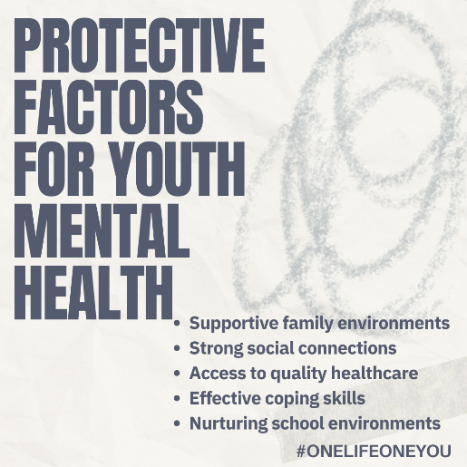
- Behind the smile, there might be a silent struggle. Reach out, ask how they're really doing. Simply being present can make all the difference. #OneLifeOneYou #YouMatter #SuicidePrevention | - https://www.canva.com/design/DAFq9rFU0uw/hd4KPliR6f2AVvLSUHy1Lw/view?utm_content=DAFq9rFU0uw&utm_campaign=designshare&utm_medium=link&utm_source=editor |  | - 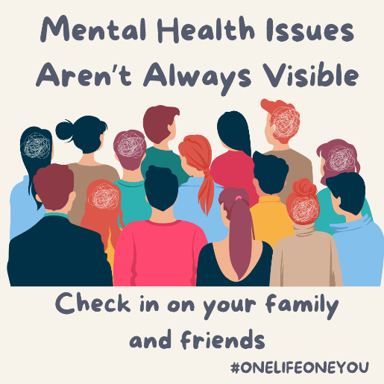
- Your presence can be a lifeline, reaching out and listening makes a difference. #OneLifeOneYou #YouMatter #SuicidePrevention | - https://www.canva.com/design/DAFq9rxOwp0/l7QoL7XvkIFC1KMANPqP1g/view?utm_content=DAFq9rxOwp0&utm_campaign=designshare&utm_medium=link&utm_source=editor |  | - 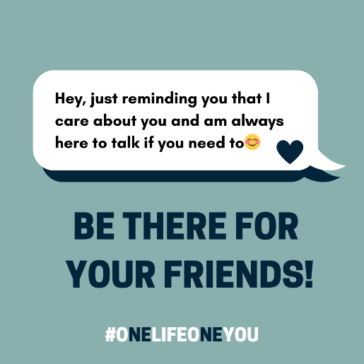
- Educate, Empathize, and Encourage. It's time to change the conversation around mental health. #OneLifeOneYou #YouMatter #SuicidePrevention | - https://www.canva.com/design/DAFq-6qH2Lg/lnh6JYLZPiIpH1FLRPoyDw/view?utm_content=DAFq-6qH2Lg&utm_campaign=designshare&utm_medium=link&utm_source=editor
- Men's mental health struggles are often left without voice. Let's raise awareness and provide support to all those struggling. #OneLifeOneYou #YouMatter #SuicidePrevention | - https://www.canva.com/design/DAF7860_Otw/9WmHABEt5mm0k5g2v9GMUw/view?utm_content=DAF7860_Otw&utm_campaign=designshare&utm_medium=link&utm_source=editor | - https://www.canva.com/design/DAF7860_Otw/9WmHABEt5mm0k5g2v9GMUw/view?utm_content=DAF7860_Otw&utm_campaign=designshare&utm_medium=link&utm_source=editor
- Recognizing the warning signs of suicide can be the first step to offering hope. Your support can change a life. #OneLifeOneYou #YouMatter #SuicidePrevention | - https://www.canva.com/design/DAF9c_h2jY0/a8p4r_ati0PMsL3Xk_FtQg/view?utm_content=DAF9c_h2jY0&utm_campaign=designshare&utm_medium=link&utm_source=editor
- From Darkness to Light: Guiding someone towards help and hope #OneLifeOneYou #YouMatter #SuicidePrevention | - https://www.canva.com/design/DAF9plZyZqU/x0AeCq4lQVw5Trg6A9Ujkg/view?utm_content=DAF9plZyZqU&utm_campaign=designshare&utm_medium=link&utm_source=editor
- Breaking the Silence: Opening Up About Suicide Can Save Lives #OneLifeOneYou #YouMatter #SuicidePrevention | - https://www.canva.com/design/DAF8nPF6sPE/Xsj5739UsLVKLjcuw0J10Q/view?utm_content=DAF8nPF6sPE&utm_campaign=designshare&utm_medium=link&utm_source=editor
- Educate, advocate, love. Change the way the world sees mental health. #OneLifeOneYou #YouMatter #SuicidePrevention | - https://www.canva.com/design/DAFiSjwgadQ/0-CXOTBXqQOgPJO91unD6w/view?utm_content=DAFiSjwgadQ&utm_campaign=designshare&utm_medium=link&utm_source=editor |  | - 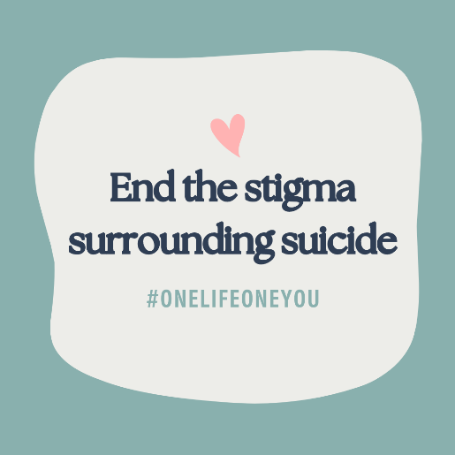
- Start the conversation early: create an open and safe space for kids to learn and discuss mental health #OneLifeOneYou #YouMatter #SuicidePrevention | - https://www.canva.com/design/DAFinlN8PTw/tgL5mYYtw1rL-3GvtFFlSg/view?utm_content=DAFinlN8PTw&utm_campaign=designshare&utm_medium=link&utm_source=editor

Resources/Help
Local and National Resources, online resources, easily accessible
Caption | Media Link | Recommended Posting Date | Photo
Society of Care assists Native American Youth in Nebraska with behavioral health concerns to succeed while working to improve systems and collaborations that support youth and their families. Check out their website and resources at : https://www.societyofcare.org/resources-1 #OneLifeOneYou #YouMatter #SuicidePrevention | https://www.canva.com/design/DAFb_SwCVUo/pbVxPrX7LOH_JxLC6zzv4w/view?utm_content=DAFb_SwCVUo&utm_campaign=designshare&utm_medium=link&utm_source=editor
You are never alone. Reach out, there is help and hope. Text or Call 988 for immediate mental health support. #OneLifeOneYou #YouMatter #SuicidePrevention | https://www.canva.com/design/DAFbU7t0qtk/WHPMdIiddXCw2Zowm_raBA/view?utm_content=DAFbU7t0qtk&utm_campaign=designshare&utm_medium=link&utm_source=editor |  | 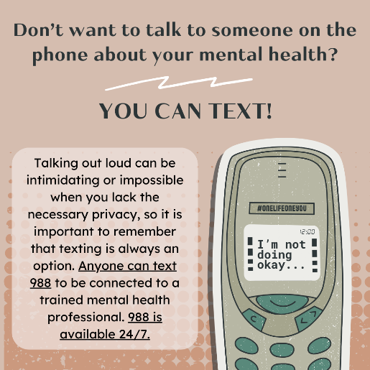
Spotlight: Resources for Native Youth. Empowering Native Youth with tools for mental wellness. Let's honor their resilience and ensure they have the support they need to thrive. #OneLifeOneYou #YouMatter #SuicidePrevention | https://www.canva.com/design/DAF7jo-YODw/SvLl-Vd_h1PM4MFsnbdd5A/watch?utm_content=DAF7jo-YODw&utm_campaign=designshare&utm_medium=link&utm_source=editor
Spotlight: Resources for Black Youth, Empowering Black Youth with tools for mental wellness. Let's honor their resilience and ensure they have the support they need to thrive. #OneLifeOneYou #YouMatter #SuicidePrevention | https://www.canva.com/design/DAFeDGvNBEs/cvNPZEPvo9RPi5QrO7DvcA/view?utm_content=DAFeDGvNBEs&utm_campaign=designshare&utm_medium=link&utm_source=editor
Spotlight: Resources for Asian-American/ Pacific Islander Youth with tools for mental wellness. Let's honor their resilience and ensure they have the support they need to thrive. #OneLifeOneYou #YouMatter #SuicidePrevention | https://www.canva.com/design/DAFeyzE8IVE/06RYHgkLCo4w-BZ_ry57zA/view?utm_content=DAFeyzE8IVE&utm_campaign=designshare&utm_medium=link&utm_source=editor
Spotlight: Resources for the Latino Community. Let's honor their resilience and ensure they have the support they need to thrive. #OneLifeOneYou #YouMatter #SuicidePrevention | https://www.canva.com/design/DAFiuj3H0-c/TzIXNytcYSoyckYGZ8Qqig/view?utm_content=DAFiuj3H0-c&utm_campaign=designshare&utm_medium=link&utm_source=editor
Spotlight: Resources for Trans Youth. Empowering Trans Youth with tools for mental wellness. Let's honor their resilience and ensure they have the support they need to thrive. #OneLifeOneYou #YouMatter #SuicidePrevention | https://www.canva.com/design/DAFeInovvZ0/A3zUsvyMUdTWMwj5OCbxdw/edit?utm_content=DAFeInovvZ0&utm_campaign=designshare&utm_medium=link2&utm_source=sharebutton
In times of need, the 988 Suicide & Crisis Lifeline stands ready to listen: reach out for a lifeline of hope 24/7 over call or text at 988. #OneLifeOneYou #YouMatter #SuicidePrevention | https://www.canva.com/design/DAFeInovvZ0/i9cIYDGc28CCYatdIKb_Cg/watch?utm_content=DAFeInovvZ0&utm_campaign=designshare&utm_medium=link&utm_source=editor |  | 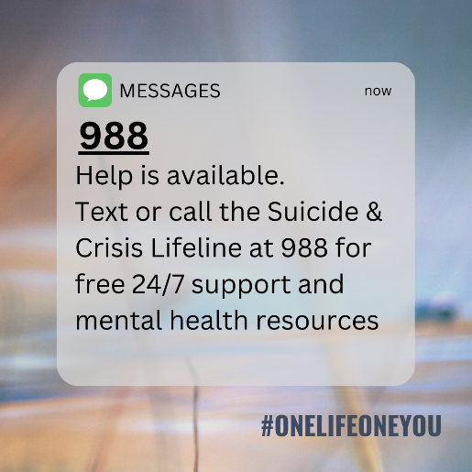
In the quiet corners of rural communities, support for mental health is vital. Wherever you are, there are resources available! Text or Call 988 for immediate mental health support. #OneLifeOneYou #YouMatter #SuicidePrevention | https://www.canva.com/design/DAFind-3xhM/4AomQyGX9OkPrUyVDD2hwQ/watch?utm_content=DAFind-3xhM&utm_campaign=designshare&utm_medium=link&utm_source=editor
If you or someone you know is struggling, remember there's always help available. Reach out to a trusted person or a lifeline. 📞 #OneLifeOneYou #YouMatter #SuicidePrevention | https://www.canva.com/design/DAFeCcEEpAs/lQg-cPqYR0OZzHoE70Cqpw/view?utm_content=DAFeCcEEpAs&utm_campaign=designshare&utm_medium=link&utm_source=editor |  | 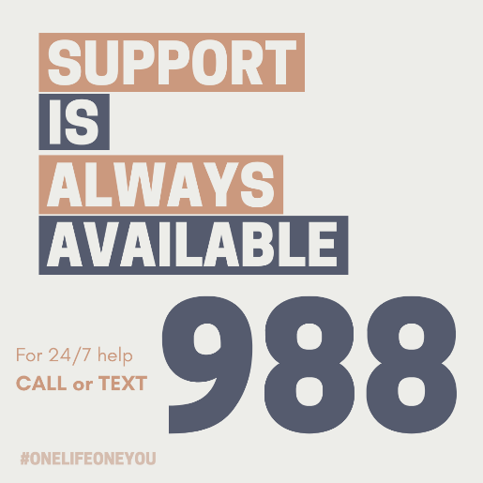
Today's challenge: take time for self-care #OneLifeOneYou #YouMatter #SuicidePrevention | https://www.canva.com/design/DAFq40X2kNk/XBuXrBepR2pXAT6ndBaZzA/view?utm_content=DAFq40X2kNk&utm_campaign=designshare&utm_medium=link&utm_source=editor |  | 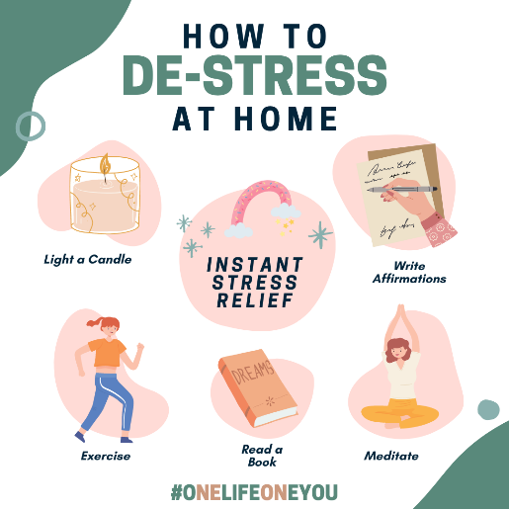
It's okay to not be okay. Help is just a call away. Dial 988 to reach trained counselors 24/7/365. 💙 #OneLifeOneYou #YouMatter #SuicidePrevention | https://www.canva.com/design/DAFq468VEzw/AfrMYUVABXfx-K1EVOLQNg/view?utm_content=DAFq468VEzw&utm_campaign=designshare&utm_medium=link&utm_source=editor |  | 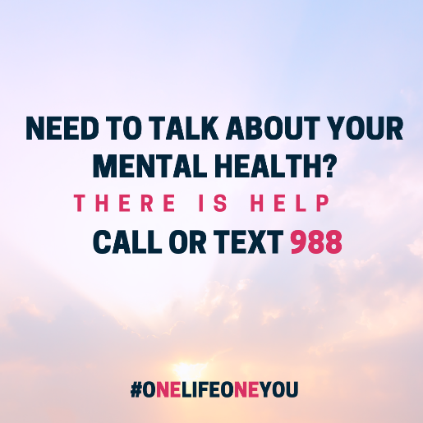
Mindfulness isn't just a practice—it's a lifeline. Embrace moments of stillness, self-awareness, and inner peace. #OneLifeOneYou #YouMatter #SuicidePrevention | https://www.canva.com/design/DAFq_BQOrac/vcmozLax3aUK73MRRTyHxA/view?utm_content=DAFq_BQOrac&utm_campaign=designshare&utm_medium=link&utm_source=editor
Your journey to mental wellness starts here! 9 Steps to positive mental health #OneLifeOneYou #YouMatter #SuicidePrevention | https://www.canva.com/design/DAFcW7z7jTo/X1kkXM3AyiFkNQLqQ45e7Q/view?utm_content=DAFcW7z7jTo&utm_campaign=designshare&utm_medium=link&utm_source=editor |  | 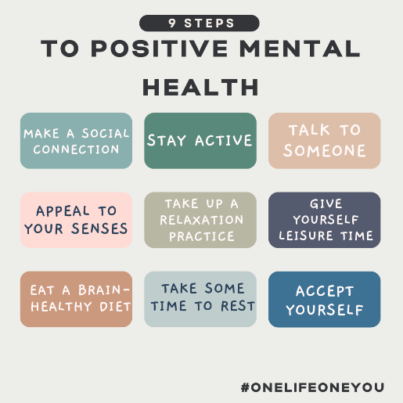
Just checking in! Have you taken some time to take care of yourself today? Even little steps can be big accomplishments! #OneLifeOneYou #YouMatter #SuicidePrevention | https://www.canva.com/design/DAF7fS4Kwgk/OL94xaK0cumV8dKl-j4z0g/view?utm_content=DAF7fS4Kwgk&utm_campaign=designshare&utm_medium=link&utm_source=editor |  | 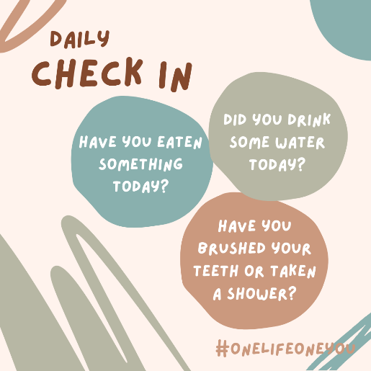
You are not alone! It's okay not to be okay. Reach out, speak up, and let's support each other. #OneLifeOneYou #YouMatter #SuicidePrevention | https://www.canva.com/design/DAFeCpLigtA/RCk-zzb9BMYpGxbywMrUzQ/watch?utm_content=DAFeCpLigtA&utm_campaign=designshare&utm_medium=link&utm_source=editor
Real Stories, Real Hope: find connection and courage on LiveThroughThis.org #OneLifeOneYou #YouMatter #SuicidePrevention | https://www.canva.com/design/DAF9pr8f2sY/sAQZvicnJ0RXCCUevuIk-A/view?utm_content=DAF9pr8f2sY&utm_campaign=designshare&utm_medium=link&utm_source=editor |  | 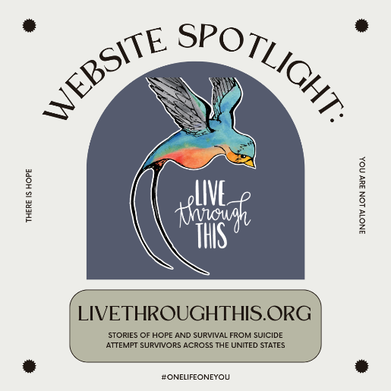

Encourage/Inspire
Normalizing and promoting help-seeking behaviors, acknowledge and validate feelings, messages of hope
Caption | Media Link | Recommended Posting Date | Photo
Every step of your mental health journey is a testament to your strength and resilience. Celebrate small victories and don't be afraid to ask for support. #OneLifeOneYou #YouMatter #SuicidePrevention | https://www.canva.com/design/DAFbZhdokoQ/LvBeIeqORmPLHSi4Ov0LYg/view?utm_content=DAFbZhdokoQ&utm_campaign=designshare&utm_medium=link&utm_source=editor |  | 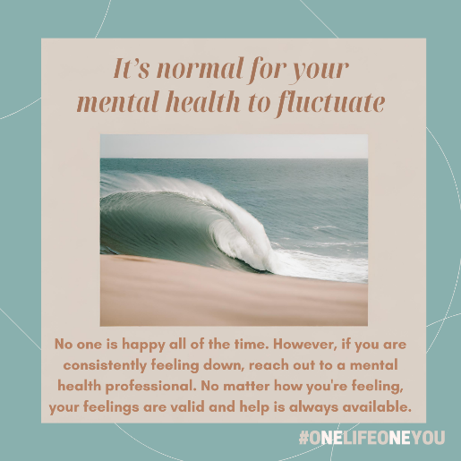
Your value isn't tied to your achievements. You are valuable just as you are, flaws and all. #OneLifeOneYou #YouMatter #SuicidePrevention | https://www.canva.com/design/DAFb-0LCPbo/Sz0tRjfKpdtmtbgJL2I_CA/view?utm_content=DAFb-0LCPbo&utm_campaign=designshare&utm_medium=link&utm_source=editor |  | 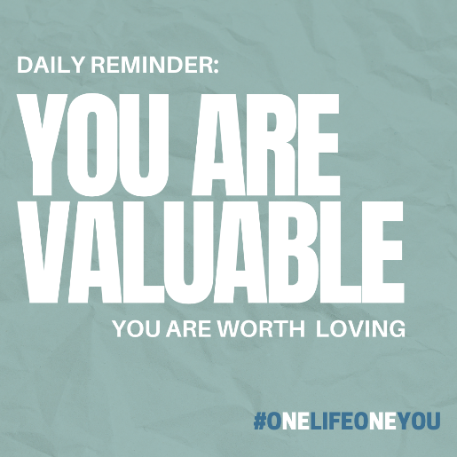
Every step you take in your mental health journey brings you closer to a brighter tomorrow. Keep moving forward. There is hope. #OneLifeOneYou #YouMatter #SuicidePrevention | https://www.canva.com/design/DAFb_hA5ehc/GqgMPO8N8mtt2A63PZYrSw/view?utm_content=DAFb_hA5ehc&utm_campaign=designshare&utm_medium=link&utm_source=editor
You are never alone in your journey. There is hope, help, and support available. #OneLifeOneYou #YouMatter #SuicidePrevention | https://www.canva.com/design/DAFb_sLdRzs/ny-L7t6ARfWaa06TJ9fQpA/view?utm_content=DAFb_sLdRzs&utm_campaign=designshare&utm_medium=link&utm_source=editor |  | 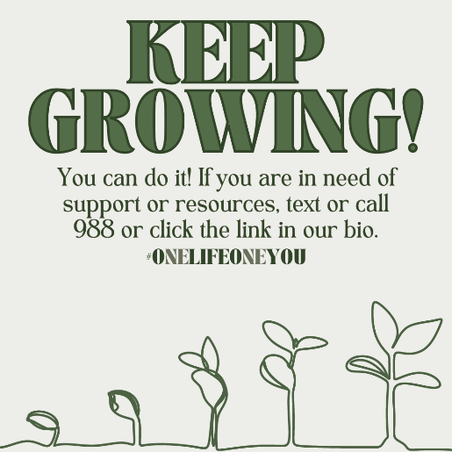
Rest is not a sign of weakness. Self-compassion includes giving yourself permission to rest. #OneLifeOneYou #YouMatter #SuicidePrevention | https://www.canva.com/design/DAFgpXKsx7g/hMdIem0_69HRBjuBfTS0Pg/watch?utm_content=DAFgpXKsx7g&utm_campaign=designshare&utm_medium=link&utm_source=editor
Your mental health journey is proof of your strength. It is the story of hope, courage, and determination. #OneLifeOneYou #YouMatter #SuicidePrevention | https://www.canva.com/design/DAFgpUkPRNw/BcPFaVT-UfdlwWgD760rcQ/view?utm_content=DAFgpUkPRNw&utm_campaign=designshare&utm_medium=link&utm_source=editor |  | 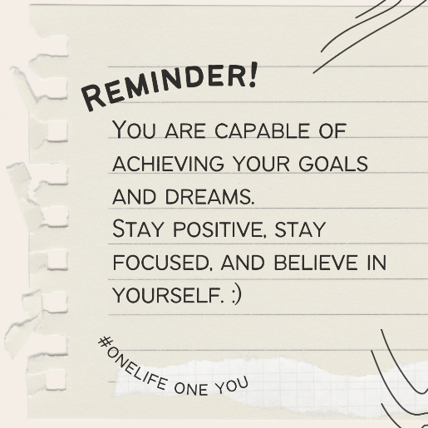
Give yourself permission to rest today. What is your favorite way to take care of your mind and body? #OneLifeOneYou #YouMatter #SuicidePrevention | https://www.canva.com/design/DAFlPQAucrk/5Gn08Fm6jB7MYvzpOcpU4g/view?utm_content=DAFlPQAucrk&utm_campaign=designshare&utm_medium=link&utm_source=editor |  | 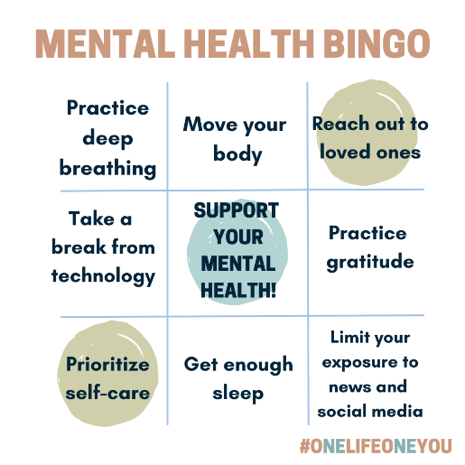
Your feelings matter because you matter. Don't let anyone minimize your experiences. #OneLifeOneYou #YouMatter #SuicidePrevention | https://www.canva.com/design/DAFlPaHLVXw/1eRcIUopyyI-PXUrRm4dRQ/view?utm_content=DAFlPaHLVXw&utm_campaign=designshare&utm_medium=link&utm_source=editor |  | 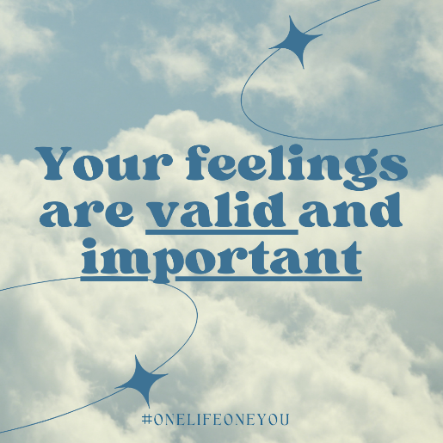
You are worthy of love and care. Just as you care for others, remember to care for yourself too. Your mental health matters.#OneLifeOneYou #YouMatter #SuicidePrevention | https://www.canva.com/design/DAF7rO0I0Fg/RegREvlVrUqNAr5LpN9nZw/view?utm_content=DAF7rO0I0Fg&utm_campaign=designshare&utm_medium=link&utm_source=editor
Your life matters more than you can imagine. You are loved and there is help available. Reach out for support by contacting 988. ❤️ #OneLifeOneYou #YouMatter #SuicidePrevention | https://www.canva.com/design/DAFlzZRLxcA/jjD0x3b7yAPsP3e5rryqxQ/view?utm_content=DAFlzZRLxcA&utm_campaign=designshare&utm_medium=link&utm_source=editor |  | 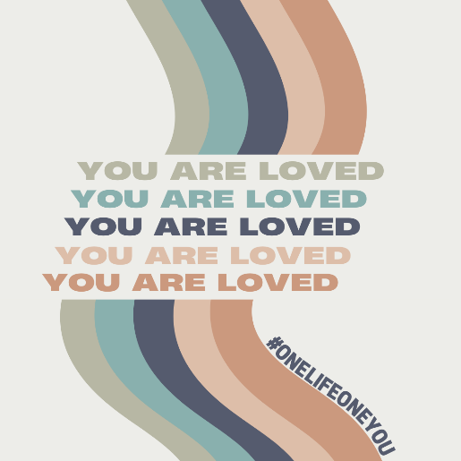
It's easy to forget your worth. Sometimes we just need a reminder! Share truth with those around you and remember your value. #OneLifeOneYou #YouMatter #SuicidePrevention | https://www.canva.com/design/DAFq4-FCeew/var2BUpGJ_7ECctiBfND9w/view?utm_content=DAFq4-FCeew&utm_campaign=designshare&utm_medium=link&utm_source=editor |  | 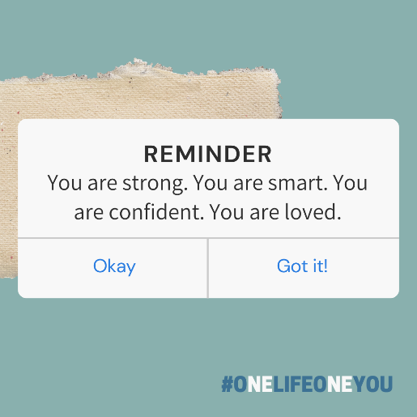
Remember, you deserve happiness and well-being. Don't hesitate to reach out for help when needed. Call or Text 988 for immediate support #OneLifeOneYou #YouMatter #SuicidePrevention | https://www.canva.com/design/DAFq9yDXrbw/LQYftVOM2c-zjlIVAL39QQ/view?utm_content=DAFq9yDXrbw&utm_campaign=designshare&utm_medium=link&utm_source=editor |  | 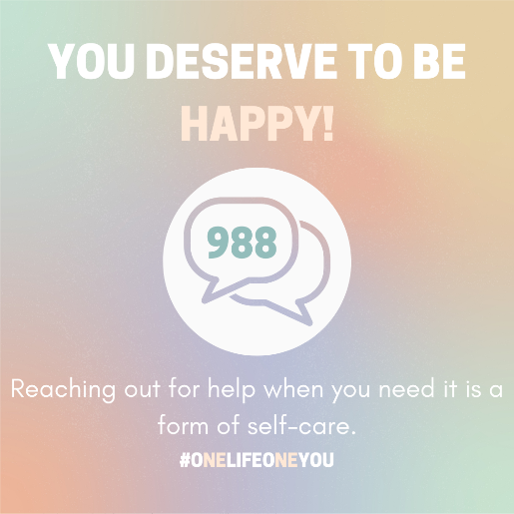
It's important to let those you care about know that you are there for them. Send this post to them as a reminder! #OneLifeOneYou #YouMatter #SuicidePrevention | https://www.canva.com/design/DAF781MB6dk/ijhN1MSmDG5eQr08c9c0DA/view?utm_content=DAF781MB6dk&utm_campaign=designshare&utm_medium=link&utm_source=editor |  | 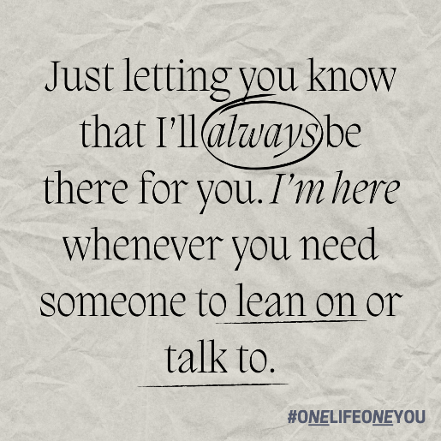
Mid-Semester Motivation: You got this! Remember, you are more than enough #OneLifeOneYou #YouMatter #SuicidePrevention | https://www.canva.com/design/DAF9dBp9zVc/LiHIXarR_CnKVFLaHuzDLg/view?utm_content=DAF9dBp9zVc&utm_campaign=designshare&utm_medium=link&utm_source=editor | Mid-Semester
Finish Strong! The End of the School Year Reflects Your Strength, Not Your Worth. You are Enough #OneLifeOneYou #YouMatter #SuicidePrevention | https://www.canva.com/design/DAF7fVNCCxs/oYCE5-NRAe8yoTlLuyKeMQ/view?utm_content=DAF7fVNCCxs&utm_campaign=designshare&utm_medium=link&utm_source=editor | End of the School Year
You are enough just as you are. #OneLifeOneYou #YouMatter #SuicidePrevention | https://www.canva.com/design/DAF9dOzLDuc/e5JgOOlZvYHEW5xJe3y39A/view?utm_content=DAF9dOzLDuc&utm_campaign=designshare&utm_medium=link&utm_source=editor |  | 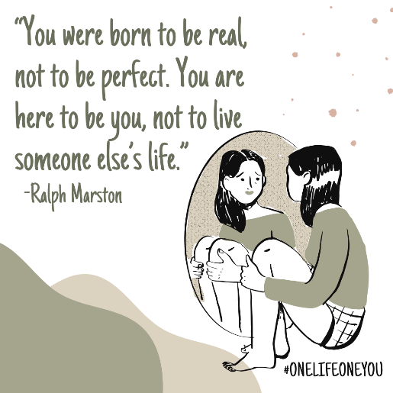
Today is better with you here. Have a great day! 😊  Send this post to someone to let them know you're thinking of them! #OneLifeOneYou #YouMatter #SuicidePrevention | https://www.canva.com/design/DAF79M6Unh4/_xGewHDUdKoUCKzm0l_mtw/view?utm_content=DAF79M6Unh4&utm_campaign=designshare&utm_medium=link&utm_source=editor |  | 
A gentle reminder: It's okay not to be okay. Check in with yourself, check in with others. Help is available ❤️ #OneLifeOneYou #YouMatter #SuicidePrevention | https://www.canva.com/design/DAFe0HlRGF4/lztrGlqKU-jebBW838oYbQ/view?utm_content=DAFe0HlRGF4&utm_campaign=designshare&utm_medium=link&utm_source=editor |  | 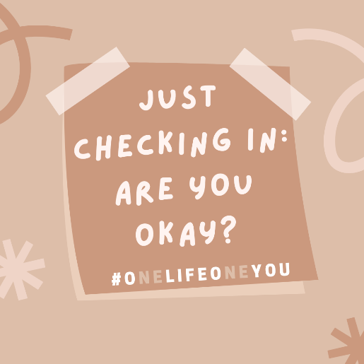
Reminder! You are important and you matter! Take some time for self-care today #OneLifeOneYou #YouMatter #SuicidePrevention | https://www.canva.com/design/DAFfjdAMG7g/ARUX_nMUkLFtb_4Jt2HKXw/view?utm_content=DAFfjdAMG7g&utm_campaign=designshare&utm_medium=link&utm_source=editor |  | 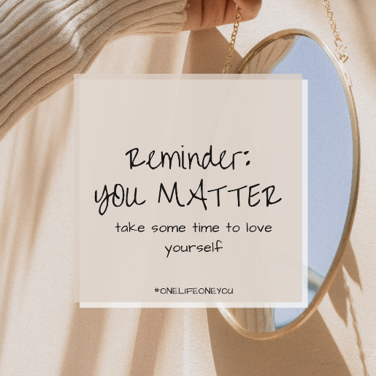
Happy Spring! May is mental health awareness month. Check in with yourself and others!🌱#OneLifeOneYou #YouMatter #SuicidePrevention | https://www.canva.com/design/DAFdkPZdzVo/ny68jQbdaLFy3mA4pCXQ8g/view?utm_content=DAFdkPZdzVo&utm_campaign=designshare&utm_medium=link&utm_source=editor | May 1st- Mental Health Awareness Month
Your life matters. You matter. You are enough just as you are. #OneLifeOneYou #YouMatter #SuicidePrevention | https://www.canva.com/design/DAFfjZVYeQs/EJKRwPJfDXRoV3abBI8eGQ/view?utm_content=DAFfjZVYeQs&utm_campaign=designshare&utm_medium=link&utm_source=editor |  | 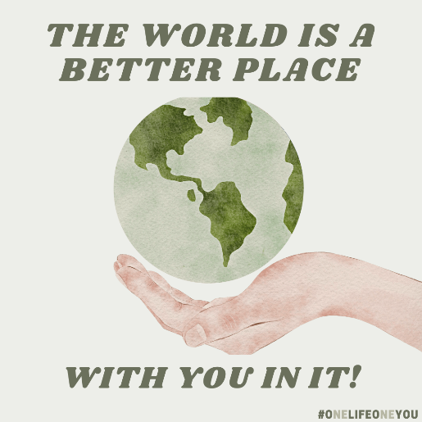
In your journey of healing you are never alone. There is help, reach out to those around you or call/text 988 for immediate assistance. #OneLifeOneYou #YouMatter #SuicidePrevention | https://www.canva.com/design/DAFdZsCqCMc/KaL03u_yyz3Fay6D2xkXjg/edit |  | 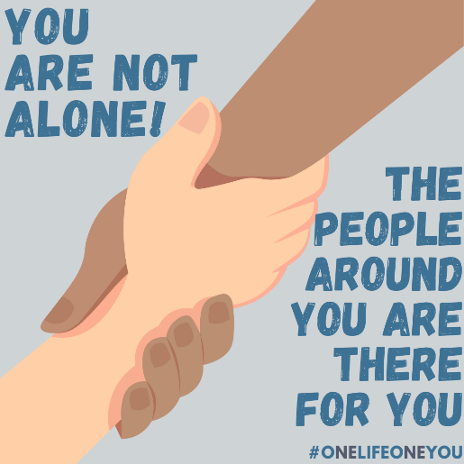
You are so special just as you are. You are enough. #OneLifeOneYou #YouMatter #SuicidePrevention | https://www.canva.com/design/DAFdZsCqCMc/CVmtunf_kSxTDNDPZjSqyw/view?utm_content=DAFdZsCqCMc&utm_campaign=designshare&utm_medium=link&utm_source=editor |  | 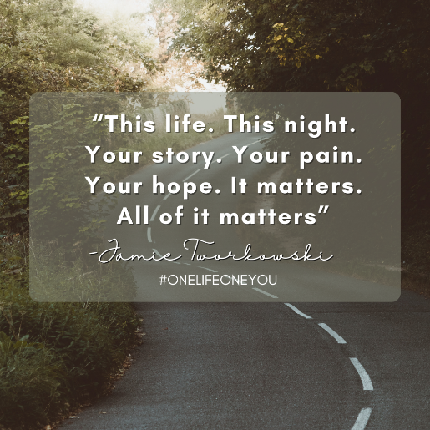
Take some time to reset and refresh today, your mind will thank you! #OneLifeOneYou #YouMatter #SuicidePrevention | https://www.canva.com/design/DAFhajA_SsU/W8O8Hy43cPzNiVZNjWJVxw/view?utm_content=DAFhajA_SsU&utm_campaign=designshare&utm_medium=link&utm_source=editor |  | 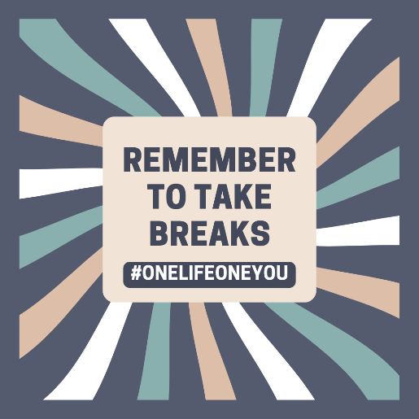
Strength isn't always about holding it together; sometimes it's about knowing when to ask for help. You are braver than you know.🌈#OneLifeOneYou #YouMatter #SuicidePrevention | https://www.canva.com/design/DAFiSvk5NeQ/UA7TFhfR5yPTVPqQqa5hAg/view?utm_content=DAFiSvk5NeQ&utm_campaign=designshare&utm_medium=link&utm_source=editor |  | 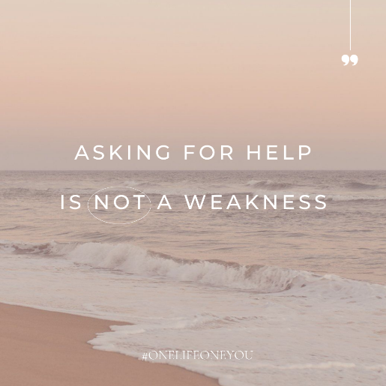
Your voice might be the comfort someone needs today. Reach out, check in, and show you care. Check in on your friends today! #OneLifeOneYou #YouMatter #SuicidePrevention | https://www.canva.com/design/DAFhaikk3aI/w5ElyGTETMHtAthK9qE0Jg/view?utm_content=DAFhaikk3aI&utm_campaign=designshare&utm_medium=link&utm_source=editor |  | 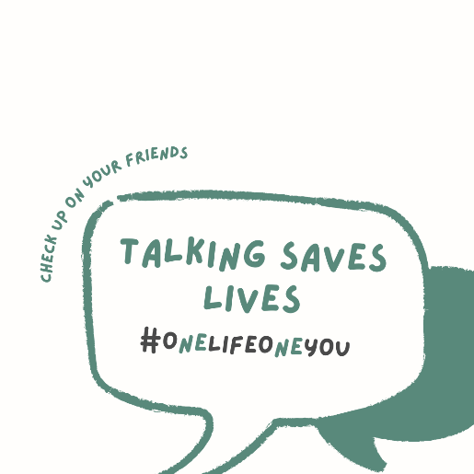
In a world that demands constant strength, remember that it's perfectly okay to ask for help. Your mental health matters and you deserve happiness. #OneLifeOneYou #YouMatter #SuicidePrevention | https://www.canva.com/design/DAFhaudY0d4/E8bU27VB2SuzCdlMMuh29w/watch?utm_content=DAFhaudY0d4&utm_campaign=designshare&utm_medium=link&utm_source=editor
It's normal and okay to be nervous about change. Remember your strength and embrace the journey. You are stronger than you know. #OneLifeOneYou #YouMatter #SuicidePrevention | https://www.canva.com/design/DAFq92vjR6o/7ha36kOw1mpoPQNw9NEzjA/view?utm_content=DAFq92vjR6o&utm_campaign=designshare&utm_medium=link&utm_source=editor |  | 